Practical File
of

Accelerated Computing with C/C++
(24CAI1104)

Batch-2024

Bachelor of Engineering (CSE-AI)



Submitted By  Sania  2410992566  Group No: 24, Sem: 2nd, BE (CSE-AI)  Chitkara University, Punjab, 140401  India | Submitted To  Mrs.Swati Malik  Assistant Professor, CSE-AI  Chitkara University, Punjab, 140401  India

Department of
Computer Science and Engineering (Artificial Intelligence),
Chitkara University School of Engineering and Technology,
Chitkara University, Punjab, India
Index

Sr. No. | Experiment | Page No.
1 | Write a program that converts temperatures between Celsius, Fahrenheit, and Kelvin using a menu-driven approach. | 4-6
2 | Write a program that accept marks for 5 subjects and calculate the grade based on the percentage using if-else or switch-case constructs. | 7-8
3 | Write a program to find all Armstrong numbers between two given numbers. | 9-10
4 | Write a function to reverse a number and check if it is a palindrome. | 11-12
5 | Write a program to find the second largest element in the given array. | 13-1`4
6 | Write a program to perform addition, subtraction, and multiplication of two matrices. | 15-18
7 | Create a program to swap two variables using call by reference and call by value. | 19-20
8 | Write a program to sort characters (numbers and punctuation symbols are not included) in a string. | 21-22
9 | Write a program to find the length of the longest word in a given string. | 23-24
10 | Define a class Student with attributes such as rollNumber, name, and marks (array of 5 subjects). Add methods to calculate the total marks, percentage, and grade of the student. Display the details of each student. | 25-27
11 | Create a class Employee with attributes id, name, designation, and salary. Add methods to:  - Set employee details.  - Calculate yearly salary.  - Display employee details. | 28-30
12 | Create a class Complex that initializes the real and imaginary parts using a default and parameterized constructor. Write a destructor to display "Complex object destroyed."
13 | Write a program to overload the function volume() to calculate the volume of a cube, a rectangular box, and a cylinder.
14 | Write a program to demonstrate how the static members are shared across all objects.

15 | Write a program to Overload the + operator in a class Vector to add two vectors represented by their x, y, and z components.
16 | Design a Bank Management System to demonstrate OOP concepts, including classes, inheritance, and polymorphism. Create a base class Account with attributes like account number, holder name, and balance, and derive SavingsAccount and CurrentAccount classes. Use constructors, destructors, static members to track total accounts, function overloading for deposit/withdrawal, operator overloading for balance operations, and a friend function for fund transfers. Include polymorphism to calculate interest dynamically for different account types.
17 | Create a program that accepts user input for a list of students (name and marks) and saves the details to a file students.txt. Then, read the file and display the details.
18 | Create a program to merge two text files into a single file. Handle errors if any file is missing or inaccessible.
19 | Write a program to create and run two threads that print messages ("Hello from Thread 1" and "Hello from Thread 2") simultaneously.
20 | Write a program to calculate the sum of a large array using multiple threads. Divide the array into equal parts, and each thread calculates the sum of its portion.

Experiment No. 1.
Aim: Write a program that converts temperatures between Celsius, Fahrenheit, and Kelvin using a menu-driven approach.
Concept Used:
If-else constructs

Program:

#include <iostream>
using namespace std;

int main() {
float temp, result;
string choice;
cout << "Enter Temperature: ";
cin >> temp;

cout << "Enter conversion choice:\n";
cout << "'C' - Celsius to Fahrenheit\n";
cout << "'F' - Fahrenheit to Celsius\n";
cout << "'K' - Kelvin to Celsius\n";
cout << "'CK' - Celsius to Kelvin\n";
cout << "'FK' - Fahrenheit to Kelvin\n";
cout << "'KF' - Kelvin to Fahrenheit\n";
cout << "Choice: ";
cin >> choice;

if (choice == "C") {
result = (temp * 9/5) + 32;
cout << "Celsius to Fahrenheit: " << result << " °F" << endl;
}
else if (choice == "F") {
result = (temp - 32) * 5/9;
cout << "Fahrenheit to Celsius: " << result << " °C" << endl;
}
else if (choice == "K") {
result = temp - 273.15;
cout << "Kelvin to Celsius: " << result << " °C" << endl;
}
else if (choice == "CK") {
result = temp + 273.15;
cout << "Celsius to Kelvin: " << result << " K" << endl;
}
else if (choice == "FK") {
result = (temp - 32) * 5/9 + 273.15;
cout << "Fahrenheit to Kelvin: " << result << " K" << endl;
}
else if (choice == "KF") {
result = (temp - 273.15) * 9/5 + 32;
cout << "Kelvin to Fahrenheit: " << result << " °F" << endl;
}
else {
cout << "Wrong input! Please enter a valid option." << endl;
}

return 0;
}

Output Screenshot:

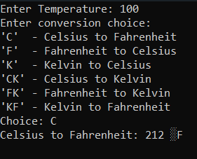

Experiment No. 2.
Aim: Write a program that accept marks for 5 subjects and calculate the grade based on the percentage using if-else or switch-case constructs.
Concept Used:
If-else constructs
Program:

#include<iostream>
using namespace std;
int main()
{
int n[5],sum=0;
cout<<"Enter marks of 5 subjects:"<<endl;
for(int i=0;i<5;i++){
cin>>n[i];
sum +=n[i];
}
float per=(sum/500.0)*100;
cout<<sum<<endl;
cout<<per<<endl;
if(per>=60){
cout<<"Grade A";
}
else if(per<60 && per>=50)
{
cout<<"Grade B";
}
else if(per<50 && per>=40)
{
cout<<"Grade C";
}
else if(per<40 && per>=33)
{
cout<<"Grade D";
}
else if(per<33)
{
cout<<"Grade F";
}
}

Output Screenshot:

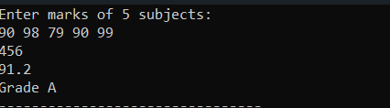

Experiment No. 3.
Aim: Write a program to find all Armstrong numbers between two given numbers.
Concept Used:
For loop (loop constructs)
Program:
//Write a program to find all Armstrong numbers between two given numbers.
#include<iostream>
#include<cmath>
using namespace std;

int main(){
int temp,num,sum,count,rem,start,end,countarm=0;
cout<<"Enter start range of interval:";
cin>>start;
cout<<"Enter end range of interval:";
cin>>end;

for(num=start;num<=end;num++){
temp=num;
count=0;
sum=0;
while(temp!=0){
temp /=10;
count++;
}
temp=num;
while(temp!=0){
rem=temp%10;
sum=sum+pow(rem,count);
temp=temp/10;
}
if(sum==num){
cout<<num <<" is an armstrong"<<endl;
countarm++;
}

}
if(countarm==0){
cout<<"None"<<endl;
}
}

Output Screenshot:

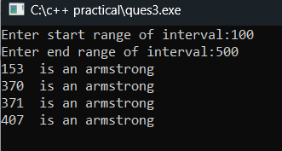

Experiment No. 4.
Aim: Write a function to reverse a number and check if it is a palindrome.
Concept Used:
If-else constructs,operators
Program:
// Write a function to reverse a number and check if it is a palindrome.
#include <iostream>
using namespace std;

int main() {
int num, temp, reversedNum = 0, digit;
cout << "Enter a number: ";
cin >> num;

temp = num;

while (temp > 0) {
digit = temp % 10;
reversedNum = reversedNum * 10 + digit;
temp /= 10;
}

if (num == reversedNum) {
cout << num << " is a palindrome.";
} else {
cout << num << " is not a palindrome.";
}

return 0;
}

Output Screenshot:

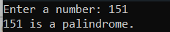

Experiment No. 5.
Aim: Write a program to find the second largest element in the given array.
Concept Used:

Program:

//Write a program to find the second largest element in the given array.
#include <iostream>
using namespace std;

int main() {
int n;
cin >> n;
int arr[n];

for (int i = 0; i < n; i++) {
cin >> arr[i];
}

// Correct initialization
int max1 = INT_MIN, max2 = INT_MIN;

// Find max1 (largest) and max2 (second largest)
for (int i = 0; i < n; i++) {
if (arr[i] > max1) {
max2 = max1; // Update second largest
max1 = arr[i]; // Update largest
}
else if (arr[i] > max2 && arr[i] < max1) {
max2 = arr[i]; // Update second largest if it's smaller than max1
}
}

// Output result
if (max2 == INT_MIN) {
cout << "No second largest element";
} else {
cout << "Second Largest: " << max2;
}

return 0;
}

Output Screenshot:

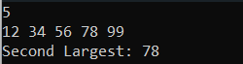

Experiment No. 6.
Aim: Write a program to perform addition, subtraction, and multiplication of two matrices.

Concept Used:
Concept of arrays
Program:
//Write a program to perform addition, subtraction, and multiplication of two matrices.
#include <iostream>
using namespace std;

// Function to perform matrix addition
void addMatrices(int A[][10], int B[][10], int result[][10], int rows, int cols) {
for (int i = 0; i < rows; i++) {
for (int j = 0; j < cols; j++) {
result[i][j] = A[i][j] + B[i][j];
}
}
}

// Function to perform matrix subtraction
void subtractMatrices(int A[][10], int B[][10], int result[][10], int rows, int cols) {
for (int i = 0; i < rows; i++) {
for (int j = 0; j < cols; j++) {
result[i][j] = A[i][j] - B[i][j];
}
}
}

// Function to perform matrix multiplication
void multiplyMatrices(int A[][10], int B[][10], int result[][10], int rowsA, int colsA, int colsB) {
for (int i = 0; i < rowsA; i++) {
for (int j = 0; j < colsB; j++) {
result[i][j] = 0;
for (int k = 0; k < colsA; k++) {
result[i][j] += A[i][k] * B[k][j];
}
}
}
}

// Function to display a matrix
void displayMatrix(int matrix[][10], int rows, int cols) {
for (int i = 0; i < rows; i++) {
for (int j = 0; j < cols; j++) {
cout << matrix[i][j] << " ";
}
cout << endl;
}
}

int main() {
int rowsA, colsA, rowsB, colsB;
int A[10][10], B[10][10], result[10][10];

// Input dimensions for matrices
cout << "Enter rows and columns for matrix A: ";
cin >> rowsA >> colsA;
cout << "Enter rows and columns for matrix B: ";
cin >> rowsB >> colsB;

// Input matrix A
cout << "Enter elements of matrix A:\n";
for (int i = 0; i < rowsA; i++) {
for (int j = 0; j < colsA; j++) {
cin >> A[i][j];
}
}

// Input matrix B
cout << "Enter elements of matrix B:\n";
for (int i = 0; i < rowsB; i++) {
for (int j = 0; j < colsB; j++) {
cin >> B[i][j];
}
}

// Perform addition and subtraction only if dimensions are the same
if (rowsA == rowsB && colsA == colsB) {
addMatrices(A, B, result, rowsA, colsA);
cout << "Matrix Addition Result:\n";
displayMatrix(result, rowsA, colsA);

subtractMatrices(A, B, result, rowsA, colsA);
cout << "Matrix Subtraction Result:\n";
displayMatrix(result, rowsA, colsA);
} else {
cout << "Addition and subtraction not possible, dimensions must be the same.\n";
}

// Perform multiplication if the number of columns in A is equal to the number of rows in B
if (colsA == rowsB) {
multiplyMatrices(A, B, result, rowsA, colsA, colsB);
cout << "Matrix Multiplication Result:\n";
displayMatrix(result, rowsA, colsB);
} else {
cout << "Multiplication not possible, columns of A must match rows of B.\n";
}

return 0;
}

Output Screenshot:

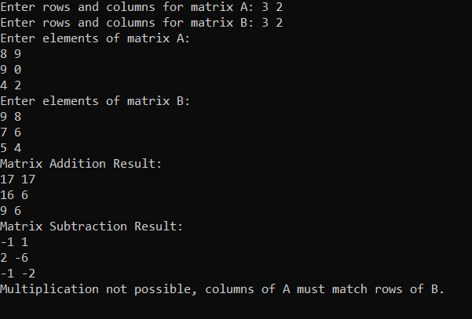

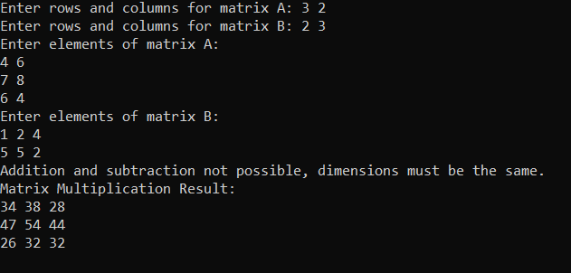

Experiment No. 7.
Aim: Create a program to swap two variables using call by reference and call by value.
Concept Used:
Functions
Program:
//Create a program to swap two variables using call by reference and call by value.
#include <iostream>
using namespace std;

void swapByValue(int a, int b) {
int temp = a;
a = b;
b = temp;
cout << "Inside swapByValue: a = " << a << ", b = " << b << endl;
}

void swapByReference(int &a, int &b) {
int temp = a;
a = b;
b = temp;
}

int main() {
int x, y;
cout << "Enter two numbers: ";
cin >> x >> y;

cout << "Before swapping: x = " << x << ", y = " << y << endl;

swapByValue(x, y);
cout << "After swapByValue: x = " << x << ", y = " << y << " (No change outside function)" << endl;

swapByReference(x, y);
cout << "After swapByReference: x = " << x << ", y = " << y << " (Values swapped)" << endl;

return 0;
}

Output Screenshot:

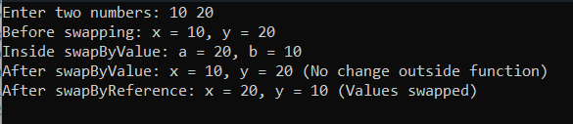

Experiment No. 8.
Aim: Write a program to sort characters (numbers and punctuation symbols are not included) in a string.
Concept Used:
Strings
Program:

#include <iostream>
#include <algorithm>
#include <cctype>
using namespace std;

int main() {
string input;
cout << "Enter a string: ";
getline(cin, input);

string letters;

for (size_t i = 0; i < input.length(); i++) {
if (isalpha(input[i])) {
letters += input[i];
}
}

sort(letters.begin(), letters.end());

if (letters.empty()) {
cout << "Sorted string: " << input << endl;
return 0;
}

int index = 0;
for (size_t i = 0; i < input.length(); i++) {
if (isalpha(input[i])) {
input[i] = letters[index++];
}
}

cout << "Sorted string: " << input << endl;

return 0;
}

Output Screenshot:

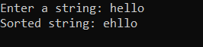

Experiment No. 9.
Aim: Write a program to find the length of the longest word in a given string.
Concept Used:
Strings
Program:

// Write a program to find the length of the longest word in a given string.
#include <iostream>
#include <sstream>
using namespace std;

int main() {
string input;
cout << "Enter a string: ";
getline(cin, input);

int maxLength = 0, currentLength = 0;
stringstream ss(input);
string word, longestWord;

while (ss >> word) {
currentLength = word.length();
if (currentLength > maxLength) {
maxLength = currentLength;
longestWord = word;
}
}

cout << "Length of longest word: " << maxLength << endl;
cout << "Longest word: " << longestWord << endl;

return 0;
}

Output Screenshot:

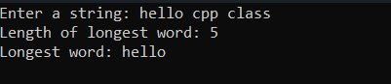

Experiment No. 10.
Aim: Define a class Student with attributes such as rollNumber, name, and marks (array of 5 subjects).
- Add methods to calculate the total marks, percentage, and grade of the student.
- Display the details of each student.

Concept Used:
Classes and Objects
Program:

//Define a class Student with attributes such as rollNumber, name, and marks (array of 5 subjects).
//Add methods to calculate the total marks, percentage, and grade of the student.
// Display the details of each student.

#include <iostream>
using namespace std;

class Student {
private:
int rollNumber;
string name;
int marks[5];

public:

void inputDetails() {
cout << "Enter Roll Number: ";
cin >> rollNumber;
cin.ignore();
cout << "Enter Name: ";
getline(cin, name);
cout << "Enter marks for 5 subjects: ";
for (int i = 0; i < 5; i++) {
cin >> marks[i];
}
}

int getTotalMarks() {
int total = 0;
for (int i = 0; i < 5; i++) {
total += marks[i];
}
return total;
}

float getPercentage() {
return getTotalMarks() / 5.0;
}

char getGrade() {
float percentage = getPercentage();
if (percentage >= 90) return 'A';
else if (percentage >= 75) return 'B';
else if (percentage >= 60) return 'C';
else if (percentage >= 50) return 'D';
else return 'F';
}

void displayDetails() {
cout << "\nStudent Details:\n";
cout << "Roll Number: " << rollNumber << endl;
cout << "Name: " << name << endl;
cout << "Total Marks: " << getTotalMarks() << endl;
cout << "Percentage: " << getPercentage() << "%" << endl;
cout << "Grade: " << getGrade() << endl;
}
};

int main() {
Student student;
student.inputDetails();
student.displayDetails();
return 0;
}

Output Screenshot:

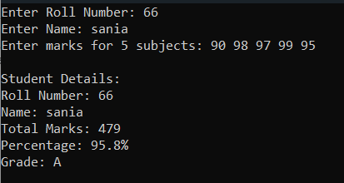

Experiment No. 11.
Aim: Create a class Employee with attributes id, name, designation, and salary. Add methods to:
- Set employee details.
- Calculate yearly salary.
- Display employee details.

Concept Used:
Classes and Objects
Program:

#include <iostream>
using namespace std;

class Employee {
private:
int id;
string name;
string designation;
float salary;

public:
void setDetails() {
cout << "Enter Employee ID: ";
cin >> id;
cin.ignore();
cout << "Enter Name: ";
getline(cin, name);
cout << "Enter Designation: ";
getline(cin, designation);
cout << "Enter Monthly Salary: ";
cin >> salary;
}

float getYearlySalary() {
return salary * 12;
}

void displayDetails() {
cout << "\nEmployee Details:\n";
cout << "ID: " << id << endl;
cout << "Name: " << name << endl;
cout << "Designation: " << designation << endl;
cout << "Monthly Salary: " << salary << endl;
cout << "Yearly Salary: " << getYearlySalary() << endl;
}
};

int main() {
Employee emp;
emp.setDetails();
emp.displayDetails();
return 0;
}

Output Screenshot:

